GUIA DE APRENDIZAJE UNIDAD 1 N° DE GUÍA: ___13__
RECURSO: TEXTO DE ESTUDIO PAGINAS: Power point
ASIGNATURA: English
NOMBRE ESTUDIANTE: ____________________CURSO: _7°_ LETRA: ______ FECHA: __________________
O.A: Demostrar comprensión de los sustantivos contables y no contables relacionándolos con how much y how many.

- look at the pictures and write under each the name of the food or object.

sugar | cheese | orange | apple | tea | milk | chocolate | time

 | 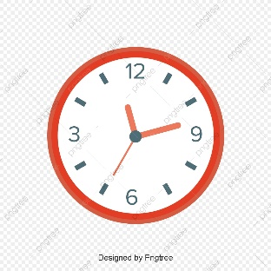 |  | 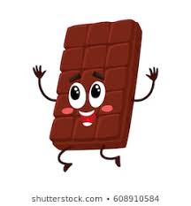

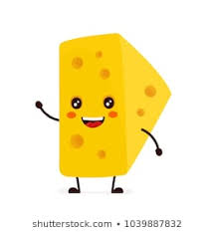 | 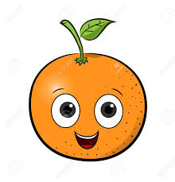 | 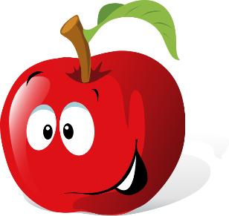 | 

II. Write the words from the activity 1 into the right boxes according to your knowledge
Example : Orange is countable

countable | uncountable

- Fill the gaps writing “much” or “many” according to the noun

EXAMPLE: How __much __ chocolate do you eat every day?
How __many __ apples do you have in your fridge?

- How ________ time do you use to play free fire?
- How ________ computers do you have?
- How ________ homework do you have this week?
- How ________ money do you save in the bank?
- How ________ oranges do you eat every week?

