GUIA DE APRENDIZAJE UNIDAD 1 N° DE GUÍA: ___9__
RECURSO: TEXTO DE ESTUDIO PAGINAS: Power point
ASIGNATURA: English
NOMBRE ESTUDIANTE: ____________________CURSO: _6°_ LETRA: ______ FECHA: __________________
O.A: Identificar ocupaciones y profesiones a través de la comprensión de lectura.

- Choose the right alternative according to the picture

1-  a) I help animals to be healthy  b) I help people to be healthy  c) I make experiments in a lab | 2-  a) I teach many children at school  b) I fix cars with my tools  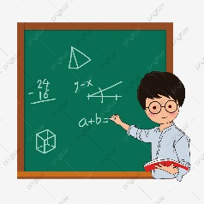  c) I take orders in a restaurant
3-  a) I paint paintings  b) I work in a farm with animals  c) I work in a kitchen | 4-  a) I keep people save of thieves  b) I extinguish the fire in a house or accident  c) I delivery letters from people
4-  a) I work in a kitchen  b) I keep people save of thieves  c) I fix cars with my tools | 6-  a) I make experiments in a lab  b) I work in a farm with animals  c) I sell food, products, and clothes
7-  a) I work in a hospital with doctors  b) I help people to be healthy  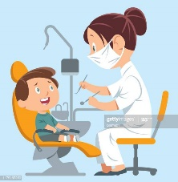  c) I fix people´s teeth | 8-  a) I fix people´s teeth  b) I delivery letter from people  c) I sell food, products, and clothes
9-  a) I take orders in a restaurant  b) I fix cars with my tools  c) I work in a farm with animals | 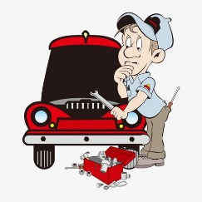  10-  a) I help animals to be healthy  b) I make experiments in a lab  c) I fix cars with my tools
11-  a) I work in a hospital with doctors  b) ) I extinguish the fire in a house or accident  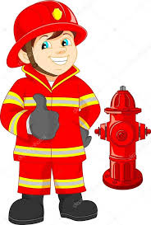  c) I fix people´s teeth | 12-  a) I work in a hospital with doctors  b) I extinguish the fire in a house or accident  c) I work in a farm with animals

- Read carefully and answer the following questions about the text.

My name is Rick, I work in a restaurant, I work 8 hours in a day, I really feel exhausted when I finish my work because the restaurant is always full , there are many people asking for different kind of food and I really love my work but I need to take a rest , I need to sleep and eat healthy because I don´t have time to eat there while I am working.
When I was a child I wanted to be teacher but suddenly I finished working in a restaurant, They pay me very well but sometimes I imagine myself in a classroom as a teacher with many students learning math or English…. I hope some day to make my dream come true.

- What is the occupation or profession of Rick?
a) his occupation is waiter
b) his occupation is chef
c) his occupation is doctor

- Why is he so tired?
a) because the restaurant is always full, so he works a lot
b) because he works 8 hours in a day
c) because he wanted to be a teacher

- What did he want to be when he was a child?
a) he wanted to be a vet
b) he wanted to be artist
c) he wanted to be a teacher

